**Korea – Hwacheon Sancheoneo Ice Festival**

The best place to enjoy winter in Korea is undoubtedly Gangwon-do province. When Hwacheoncheon Stream, located in Hwacheon-gun, Gangwon-do – freezes in winter, locals and tourists flock to the stream, cut a hole in the ice, and begin ice fishing in search of sancheoneo (fish) Masou's period). Salmon are known to live only in high quality freshwater. The excitement of fishing in the cold is so great that some visitors even choose to jump into the icy waters of the pool built beside the stream with shorts and a t-shirt to catch fish by hand. Lots of fun activities with snow and ice make the Hwacheon Sancheoneo Ice Festival one of the best winter destinations

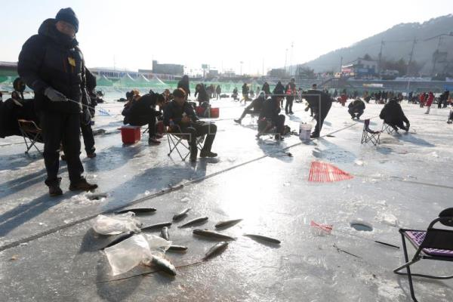

Sancheoneo Fishing Festival

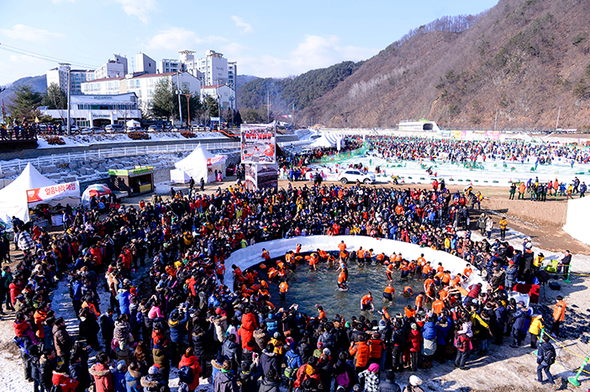

The Sancheoneo Fishing Festival is the main activity at the Hwacheon Sancheoneo Ice Festival. There are three ways for visitors to fish at the festival: fishing on the icy river, fishing in flowing waters, and hand-catching in the pool. Alternatively, visitors can get the fish they catch to be served fried or sliced raw at the food stalls.

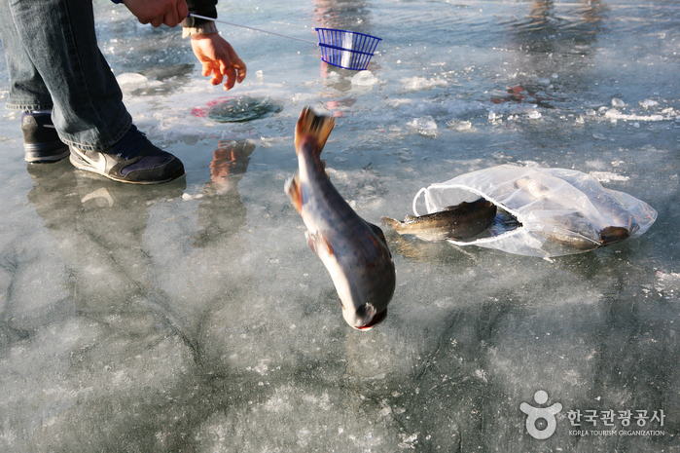

Catching fish by hand is probably the most exciting activity at the festival. This style of fishing is perfect for visitors who really want to get in on the action. Registration is a simple on-site process and each participant is given a festive t-shirt and shorts to change into. After the event is over, the participants can relieve the cold on their feet by taking a warm bath.

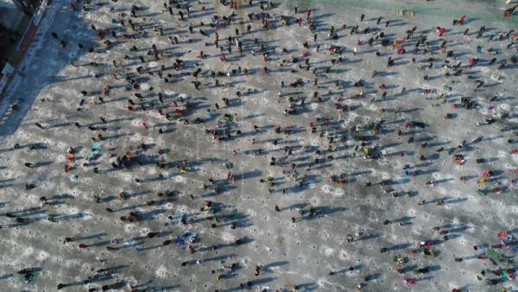

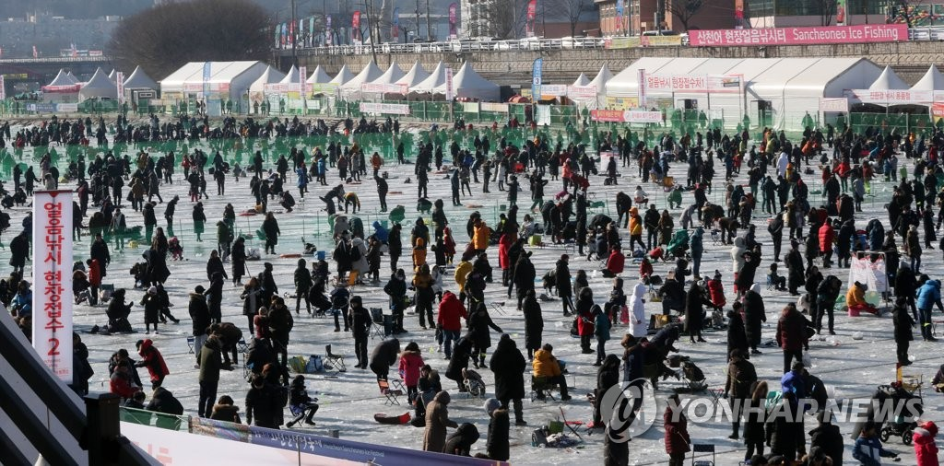

If you're not feeling well enough, you can enjoy ice fishing on Hwacheoncheon Stream. This is the most iconic event of the festival, taking place on ice at least 30 centimeters thick. The festival is also preparing to round off an exclusive ice for international visitors to increase the chances of catching fish.

Outdoor fun in the snow

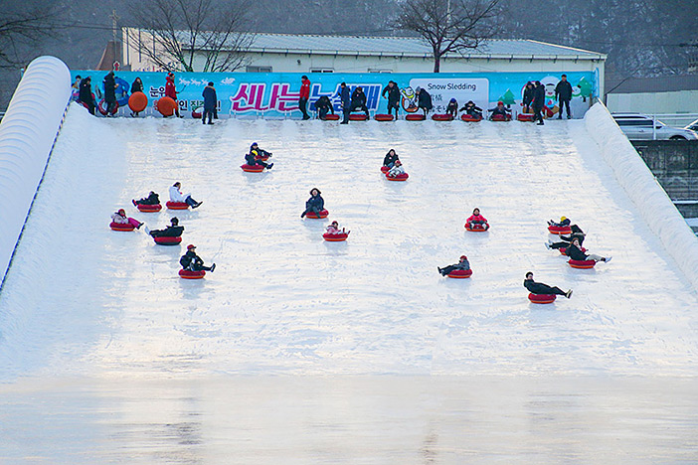

Snow and ice activities are another core part of the Hwacheon Sancheoneo Ice Festival. The thrilling sleigh ride down the hill and the toboggans is always a thrill. Sports enthusiasts and active people will enjoy a variety of winter sports experiences, such as soccer, curling, roller skates, and more. A swing line has also been installed above the frozen waters for the more daring visitors.

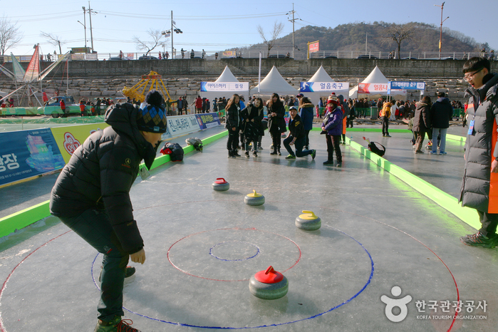

The excitement of the Hwacheon Sancheoneo Ice Festival can also be felt throughout the town of Hwacheon. Visitors can find sancheoneo-shaped lanterns made from hanji paper and beautiful LED displays at the Festival of Streets and Lights. In addition, large-scale ice sculptures are on display at Hwacheoneo Cinema, making it the largest indoor ice sculpture square in the world. Other festivals to enjoy include traditional Korean folk games and a photo gallery. Across the festival area and the city, restaurants serving raw and fried fish, as well as tteokbokki (fried rice cakes), fish cakes, and other sweet and savory fritters can be found.

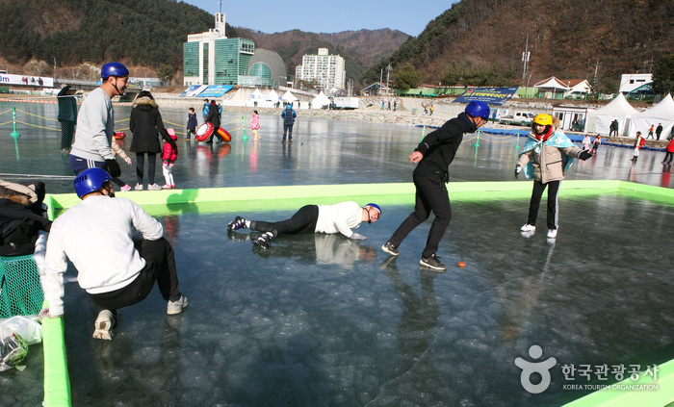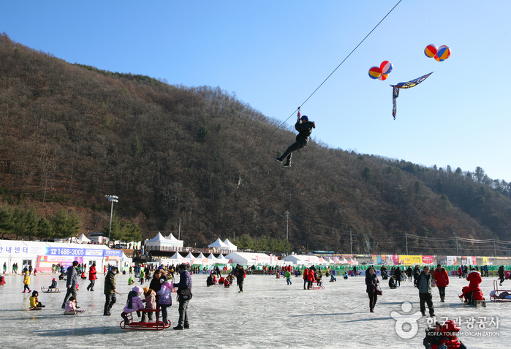

This is a perfect time to enjoy some local specialties